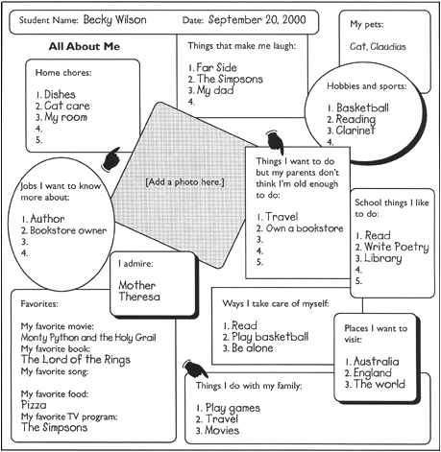

Things I would like to be able to do better:

1.

2.

3.

4.